  BAMBOO STRIP FLOORING  Plyboosport®  edge grain natural  product specification  in CSi 3-part format | Smith & Fong Company  475 – 6th Street  San Francisco, CA 94103  Direct: (952) 938-5450  Phone: (415) 896-0577  Toll Free: (800) 939-7397  Fax: (415) 896-0583  Website: www.plyboosport.com  E-mail: lear@plyboosport.com      The mark of responsible forestry  SW-COC-003124  ©1996 Forest Stewardship Council A.C.
*************************************************************************************
GENERAL NOTES TO SPECIFIER:

PLEASE GO TO wWW.PLYBOOsport.COM and check in the specifications section TO VERIFY THIS IS THE MOST CURRENT VERSION.

THE FOLLOWING PRODUCT SPECIFICATION LANGUAGE IS INTENDED TO ASSIST DESIGN PROFESSIONALS IN specifying plyboosport® bamboo sports floor surfaces in EXISTING 3-part specifications FOR PROPRIETARY or non-proprietary sports floor systems.

THIS PRODUCT SPECIFICATION SPECIFIES THE BAMBOO STRIP GYMNASIUM FLOOR SYSTEM CONSISTING IN GENERAL OF BAMBOO FLOORING, WOOD SUBFLOORING, RUBBER pads, VAPOR BARRIER, AND RELATED SURFACE FINISHING. THE CONICAL SUBFLOor construction REFERENCE IS LOCATED IN pART 2: MATERIALS, AND PART 3: INSTALLATION.

SAMPLE LANGUAGE IS PROVIDED FOR APPLICABLE ARTICLES IN

PART 1–GENERAL,

PART 2–PRODUCTS,

part 3–execution FOLLOWING THE CONSTRUCTION SPECIFICATION INSTITUTE’S SECTIONFORMAT 4.0. BECAUSE OF THE VARIATION IN SPECIFICATION SYSTEMS CURRENTLY IN USE, ARTICLE AND PARAGRAPH numbers and TITLES MAY DIFFER SOMEWHAT THAN PRESENTED HEREIN. THE SAMPLE LANGUAGE SHOULD BE EDITED ACCORDINGLY TO FIT EACH FIRM’S SPECIFICATIONS.

ARTICLES AND PARAGRAPHS OF THIS PRODUCT SPECIFICATION ASSUME THE PROJECT MANUAL WILL CONTAIN COMPLETE DIVISION 1 DOCUMENTS INCLUDING 01 25 13−PRODUCT SUBSTITUTION PROCEDURES, SECTIONS 01 33 00−SUBMITTAL PROCEDURES, 01 62 00−PRODUCT OPTIONS, 01 66 00−PRODUCT STORAGE AND HANDLING REQUIREMENTS, 01 74 00−cLEANING and waste management, 01 77 00−CLOSEOUT PROCEDURES, AND 01 78 00−CLOSEOUT SUBMITTALS. CLOSE COORDINATION WITH DIVISION 1 SECTIONS IS REQUIRED. IF THE PROJECT MANUAL DOES NOT CONTAIN THESE SECTIONS, ADDITIONAL INFORMATION MAY BE INCLUDED UNDER THE APPROPRIATE ARTICLES.

NOTES TO THE SPECIFIER ARE IN ALL UPPER CASE TEXT AND ARE CONTAINED within rows of asterisks.

GREY HIGHLIGHTED GREEN TEXT AND NOTES RELATE TO LEED® PROJECTS.

OPTIONAL ITEMS REQUIRING SELECTION BY THE SPECIFIER ARE ENCLOSED WITHIN BRACKETS, E.G. [35] [40] [45]. MAKE APPROPRIATE SELECTIONS AND DELETE OTHERS.

SECTION 09 64 66
Wood Athletic Flooring

PART 1 – GENERAL

  - SUMMARY/DESCRIPTION

  - PlybooSport is a high performance certified gymnasium and athletic flooring system utilizing a bamboo flooring top, and a dual layer plywood underlayment with multi-stage resilient pads affixed to the bottom underlayment panel.

This FSC-certified, FloorScore®-certified, FIBA compliant, DIN & EN-rated system is designed for gymnasiums, athletic courts, aerobics, dance, and exercise applications.

  - Related Sections
*************************************************************************************

IN THE “RELATED SECTIONS” PARAGRAPH INCLUDE ALL DIVISION 01 SECTIONS CONTAINING LEED® REQUIREMENTS.

ADD TO, OR DELETE FROM LIST BELOW TO CREATE AN ACCURATE LIST OF ALL APPROPRIATE SECTIONS FOR MATERIAL INSTALLED IN CONTACT WITH THE BAMBOO STRIP FLOORING.

ADD TO LIST BELOW SECTIONS FOR FINISHED TRIM NOT INCLUDED IN THIS SPECIFICATION.
********************************************************************************

Section 03 30 00 – Cast-in-Place Concrete

(Floor slab placement, tolerancing, and finishing) Coordination with built-in sleeves.

Section 06 16 23 – Subflooring

Section 06 16 26 – Underlayment

Section 07 10 00 - Membrane Waterproofing
Concrete subfloor shall have adequate moisture barrier beneath and at the perimeter of the slab.

Section 08 71 00 – Finish Hardware – Thresholds, Baseboard

Section 11 49 00 – Gymnasium Equipment/Game Standards/Sleeves/Inserts

Section 23 09 00 – Instrumentation and Control for HVAC

Section 23 84 00 – Humidity Control Equipment

Section 01 04 00 - Submittals

1.02 REFERENCES

DIN – Deutsches Institute for Normung Performance Standard 18032-2

EN – European Union Performance Standard 14904 – World Standard

FSC – Forestry Stewardship Council

LEED® – Leadership in Energy and Environmental Design

USGBC – United States Green Building Council

ASTM – American Society for Testing and Materials

NWFA – National Wood Flooring Association

MFMA – Maple Flooring Manufacturers Association

PUR – Performance Uniformity Ratings

FloorScore® – Resilient Floor Covering Institute (RFCI) and Scientific Certification Systems (SCS)

1.03 QUALITY ASSURANCE

Qualifications
*************************************************************************************
INCLUDE THE FOLLOWING MANUFACTURER’S QUALIFICATIONS:
*************************************************************************************

MANUFACTURER:

Bamboo Flooring Manufacturer’s Qualifications:

Minimum 15 years producing bamboo flooring and minimum five (5) years producing bamboo sports floors.

Manufacturer of bamboo flooring must be FSC, ISO 9000 and ISO 14001 certified to assure forestry, environmental and quality control of materials provided.

Basis of design to be “PlybooSport” sports floor system as provided by

Smith & Fong: PlybooSport LLC … 800.939.7397 … www.plyboosport.com

Materials other than those listed from non-approved manufacturers will not be accepted.

Installer Qualifications:

Minimum five (5) years experience installing sports floors.

The installation of the floor system in these specifications shall be completed by an experienced sports floor installer (Flooring Contractor) familiar with the requirements of the system specified and fully experienced in procedures required to install athletic flooring manufactured by PlybooSport.

Installer shall be liable for all matter related to installation for a minimum period of 1 year after the floor has been substantially installed and completed.

Installer must have PlybooSport installation credentials.

Performance Testing:

Bamboo flooring system shall have been tested and CERTIFIED to the International Standards: DIN 18032-2 and/or EN 14904.

Independent DIN testing laboratory shall have Scientific Body Membership in the International Association of Sports Surface Science (ISSS) with test equipment calibrated and certified through ISSS.

Independent DIN testing laboratory must be recognized by the MFMA and test to all the required standards of DIN testing methodologies.

*************************************************************************************
INCLUDE THE FOLLOWING PRE-INSTALLATION MEETING REQUIREMENTS:
*************************************************************************************

B. Pre-Installation Meeting:

Convene meeting at project site within one week of scheduled start of installation with representatives of the following in attendance: Owner, Architect, General Contractor, Flooring Sub-Contractor.

Review substrate conditions, requirements of related work, installation instructions, storage and handling procedures, and protection measures.

Keep and distribute minutes of meeting including responsibilities of various parties and deviations from specifications and installation instructions.

1.04 SUBMITTALS:

- Specification:
- Submit PlybooSport specification sheets, FSC certification and FloorScore® certificate.

Shop Drawing:
- Submit layout and installation shop drawings as requested by Specifier.
- Submit dimensional plans including location of all inserts, support sleeves, game lines, and logos.

Samples:
- Submit sample of assembled system as specified and requested by Specifier
- Submit 12” lengths of accessories, including bases, threshold, and striping paint colors

- Quality Assurance Submittals / Certificates:
- Submit Proof of Manufacturer’s Qualifications
- Submit Proof of Installing Contractors’ Qualifications
- Submit DIN certification according to 18032-2 protocol
- Submit EN certification according to 14904
- Submit FSC certification
- Submit LEED submittals for MRc6, MRc7, IEQc4.3 contributions
- MRc6, Rapidly Renewable Materials: Bamboo flooring [manufacturer’s product data for each product used, indicating that product(s) are manufactured from a rapidly renewable resource]
- MRc7, Certified Wood: Forest Stewardship Council [chain of custody certification verification from supplier of bamboo product(s)]
- IEQc4.3, Low-Emitting Materials – Flooring Systems (no added formaldehyde) [manufacturer’s product data and/or FloorScore certificate]
- Installer Supplied:
  - IEQc4.4, Low-Emitting Materials: Underlayment materials supplied by installer (manufactured with no added urea-formaldehyde)
  - IEQc4.1, Low-Emitting Materials: Adhesives and/or sealants [manufacturer’s product data]
  - IEQc4.2, Low-Emitting Materials: Paints and/or coatings [manufacturer’s product data for field finished floor coatings]
- Submit FloorScore certification
- Submit ISO 9000 and 14001 certifications
- Submit Manufacturers recommended installation instructions
- Submit Jobsite Test reports as requested by Specifier
- Air flow/ventilation testing
- Humidity level testing
- Room temperature testing
- Product moisture content testing
- Delivery and Storage reports

- Submit Maintenance Guidelines as requested by Specifier
- MSDS data
- Care, Maintenance and Service Guidelines
- HVAC temperature and humidity requirements
- Submit PlybooSport warranty

  - WORKING CONDITIONS, DELIVERY, STORAGE AND HANDLING

*************************************************************************************
INCLUDE FOLLOWING REQUIREMENTS IN THE “DELIVERY, STORAGE AND HANDLING“ ARTICLE:
*************************************************************************************
- Deliver bamboo flooring to Project site in original, unopened cartons, after all wet trades and overhead work is completed. The Building shall be full enclosed, weather-tight, with all permanent heat, light, windows, and doors installed.

Acclimatize bamboo flooring on site by opening all boxes, testing moisture level, and let acclimate to room temperature and humidity conditions for a minimum of 72 hours before installation.

During and after installation, the building HVAC systems shall maintain a temperature and humidity range compatible with the expected high and low moisture content range of the flooring. The floor installer, based on the building’s HVAC control and geographic situation shall determine this range.

- Comply with MFMA Handling and Storage guidelines.
The concrete substrate shall determined fully cured by industry standards, free of foreign materials and broom cleaned when turned over to the floor installer.

Permanent HVAC units shall be operating one week prior to sports floor installation startup Moderate room temperature of not less than 55°F (18°C) or more than 70°F (21°C) shall be maintained one week or more preceding, during and after the installation.

- Humidity: All wood and bamboo flooring will expand and contract as relative humidity varies. PlybooSport bamboo sports flooring is manufactured at a moisture content most compatible with a 35% to 50% relative humidity range. Humidity conditions within the building shall approximate conditions which will prevail when the building is occupied. Care should be taken to maintain humidity within the range of 35% to 50%. Maintaining a 15% maximum fluctuation between highest and lowest average indoor relative humidity provides optimal conditions.

- Bamboo flooring must be stored on site in a dry, well-ventilated area, not in contact with masonry while acclimating to site conditions. Moisture content shall be 6 – 9 % and consistent with the ambient conditions of the building as it will be maintained while occupied.

- General Contractor shall lock floor area after floor is finished to allow proper curing time. If general contractor or owner requires use of area, they shall protect the floor by covering with no-marring Kraft paper or red rosin paper with taped joints until acceptance by owner of completed floor.
1.06 WARRANTY

*************************************************************************************
INCLUDE THE FOLLOWING WARRANTY:
*************************************************************************************

Smith & Fong PlybooSport warrants that the sports flooring sold under this warranty is at time of sale, free of defects in material and manufacture and adheres to PlybooSports specifications. PlybooSport warrants that when professionally installed and maintained in accordance with manufacturer’s instructions and used for intended purposes, PlybooSport will not delaminate as a result of a manufacturing defect for a period of 1 year from date of sale (herein considered warranty period)

Warranty shall not cover damage in whole or in part by casualty, ordinary wear and tear, abuse, use for which materials are not designed, faulty installation, faulty construction of the building, settlement of building walls or concrete slab, failure of other contractors, separation of concrete slab, excessive dryness or excessive moisture from humidity, spillage, migration through concrete slab, walls or any other source. Abuse, vandalism, neglect, and improper installation or maintenance procedures will negate warranty.

During the warranty period, the floor shall not be recoated without the approval of the installing flooring contractor.

PART 2 – PRODUCTS

2.01 MANUFACTURER

    - Smith & Fong Company, San Francisco, CA 94103
  - Tel: (800) 939-7397.
  - E-mail: lear@plyboosport.com
  - Direct: (952) 938-5450
  - Website: http://www.plyboosport.com

2.02 MATERIALS

- PlybooSport bamboo flooring product code: FL-V3472SFN-NAF/FSC

Species: Moso (Phyllostachys Pubescens)

Formaldehyde-free

FSC certified

FloorScore certified

DIN and EN certified

Plank size: ¾” (19mm) thick by 2-1/4” (57mm) wide by 72” (1,828mm) in length (one piece construction)

Edge configuration: Square edge with Tongue and groove, 4 sides, end matched

Color: Sport Natural: Edge (vertical) grain orientation

Physical/Mechanical Properties:

FLAMMABILITY: ASTM E648: Critical Radiant Flux, Class 1

SMOKE DENSITY: ASTM E622: max 270 flaming mode, 330 non flaming mode

HARDNESS: ASTM D1037: Hardness (Janka Ball Test), 1,750 lbf

DIMENSIONAL STABILITY: ASTM D1307-99: Dimensional Stability, AR to 20% RH

Linear Expansion: Parallel -0.04%, Perpendicular -0.10%;
          - Thickness Swell: -0.13%

TENSILE STRENGTH: ASTM D3500 minimum 15,300 psi (parallel to grain)

COMPRESSIVE STRENGTH: ASTM D 3501: minimum 7,600 psi parallel to grain, 2,624 psi perpendicular to grain

MOISTURE CONTENT ASTM D4442: Moisture Content, 6% – 9% (average range)

ORGANIC EMISSIONS (Formaldehyde) ASTM D5116-06: [CA Section 01350]

Office scenario / Classroom scenario: Pass / Pass

DIN 18032-2 (Order of results: Average, Minimum, Maximum)

Multi-Use-W
- Ball Rebound: 96% avg. / 93% min. / 97% max.
- Force Reduction: 54% avg. / 52% min. / 57% max.
- Vertical Deflection: 2.8 mm avg. / 2.5 mm min. / 3.2 mm max.
- Area Indentation: 15% avg. / 13% min. / 20% max.
- Rolling Load (1500 N; 337 lbf): Pass

EN 14904 (Order of results: Average, Minimum, Maximum, Type)

Pro-B
- Ball Rebound: 97% avg. / 96% min. / 98% max.
- Force Reduction: 46% avg. / 42% min. / 49% max. / Type 3
- Vertical Deformation: 2.1 mm avg. / 1.5 mm min. / 2.7 mm max. / Type 3
- Rolling Load (1500 N; 337 lbf): Pass
          - Soft Touch-Y
- Ball Rebound: 90% avg. / 87% min. / 92% max.
- Force Reduction: 62% avg. / 58% min. / 65% max. / Type 4
- Vertical Deformation: 3.5 mm avg. / 3.1 mm min. / 4.2 mm max. / Type 4
- Rolling Load (1500 N; 337 lbf): Pass

- Conical Sub-floor:
1. Vapor barrier: 6 mil. Polyethylene.
2. Sub-floor: 2 layers of ½”(12.7mm) APA Rated Sheathing, minimum 4-ply. Exposure 1
3. Conical/pyramid Rubber Pads: 5/8”x1.5”x2.5”(16mmx38mmx64mm) as supplied by PlybooSport.

- Accessories:
1. Fasteners: 2 inch (50 mm) barbed flooring cleats, 7d or 8d galvanized flooring nail, or 2-inch (50 mm) 15 gauge coated staples with ½ inch (13 mm) crown. Modify nail size in accordance with MFMA recommendations depending on conical sub-floor system.

- Finish Materials: Consult MFMA approved manufacturer for recommended finish materials.

- Game Lines: Compatible with Finish and as specified by layout design.

- Wall Base – as specified, Heavy Duty, molded or fabricated, vented cove base with pre-molded/pre-fabricated corners recommended.

- Solid blocking support shall be installed at doorways, under stacked bleachers, below portable goals and where heavy loads are anticipated.

PART 3 – EXECUTION

*************************************************************************************
MODIFY THE FOLLOWING ARTICLE AS APPROPRIATE:
*************************************************************************************
3.01 INSPECTION

- Inspect concrete slab for tolerance and dryness, and document/report any discrepancies to the general contractor/owner/specifier for rectification.

Slab depression is: 2-3/8” (60mm) for PlybooSport ST, MULTI and PB systems.

The general contractor shall furnish and install the concrete subfloor depressing the slab sufficiently to accommodate the floor system. The slab shall be troweled smooth to a tolerance of 1/8” (3mm) in any 10’(3m) radius by the general contractor. High spots shall be ground down and low spots filled in with approved leveling compound by the general contractor to the full approval of the sports floor installer.

- The concrete slab will be dry, free of all debris and contaminants, and broom cleaned.

- Floor installer shall document site and working conditions prior to and during installation. This documentation shall become part of jobsite pedigree and warranty.

- Substrate Moisture Testing :

  - Document wood substrate moisture content.

  - Document moisture content of PlybooSport material (set meter to 0.61 for specific gravity).

  - Do not install PlybooSport if wood substrate exceeds 12% moisture or if moisture content difference between PlybooSport material and wood substrate exceeds 3% difference.

  - Document use of Calcium Chloride Test in accordance with ASTM F-1869.

  - Do not install PlybooSport flooring if vapor emission from Calcium Chloride exceeds 3lbs moisture/1,000 ft²/24 hours (15g per m²).

AND/OR

  - Document use of RH In-Situ Relative Humidity Test ASTM F-2170.

  - Do not install PlybooSport flooring if RH test exceeds 75%.

- Documented tests results are required for PlybooSport warranty.

3.02 INSTALLATION

- Subfloor:

Inspect concrete slab for tolerance and dryness, and document/report any discrepancies to the general contractor/owner/specifier for rectification.

Slab depression is: 2-3/8” (60mm) for PlybooSport ST, MULTI and PB systems.

The general contractor shall furnish and install the concrete subfloor depressing the slab sufficiently to accommodate the floor system. The slab shall be troweled smooth to a tolerance of 1/8” (3mm) in any 10’ (3m) radius by the general contractor. High spots shall be ground down and low spots filled in with approved leveling compound by the general contractor to the full approval of the sports floor installer.
    - Cover entire concrete slab with 6 mil. polyethylene, lapping joints a minimum of 6 -inches (152.4mm) and tape the seams with 2’ (50mm) duct tape
    - Install first layer of ½” (12.7mm) sub-floor plywood 90 degrees perpendicular to finished flooring. Allow ¼” (6.35mm) spacing at all edges and breaking joints every 4-feet (1.2m). Allow 1.5” (38.1mm) expansion voids at perimeter, and all vertical obstructions. The underside of the first layer shall have 32 PlybooSport conical cushion pads (5/8” x 1.5” x 2.5”, or 19mm x 38.1mm x 63.5mm) per sheet attached 12” (304.8mm) on center and 6”(152.4mm) from edges on all sides with ¼” (6.35mm) spacing between adjoining sheets (diagram enclosed).
    - Install the second layer of ½” (12.7mm) sub-floor material diagonally at a 45 degree angle over the first layer, allowing ¼” (6.35mm) spacing on all edges and breaking joints every 4’ (1.2m). Fasten second layer of sub-floor material with 1” (25.4mm) coated nails, staples, or screws 12” (304.8mm) on center.
    - Install solid blocking at doorways, under bleachers in the stacked position, below portable goals and where heavy loads are anticipated.
    - Provide 2.0” (50mm) expansion void at perimeter and all vertical obstructions.

- Bamboo Flooring:
- Install bamboo flooring parallel with main playing court by power nailing or stapling approximately 12” (304.8mm) on center with end joints properly driven tight.
- Allow spacing between flooring strips for intermediate expansion in accordance with local humidity conditions and MFMA guidelines.
- Install vented cove base over perimeter voids and metal thresholds at doorways.
- Provide 2.0” (50mm) expansion void at the perimeter and at all vertical obstructions.

3.03 FLOOR FINISHING

- Sanding:
  - Machine sand to a smooth, even and uniform surface free from edger marks, drum drops, and stop marks.
  - Remove all sanding dust and lint by tack and vacuum.
  - Refer to MFMA/industry standards for finishing procedures.

- Finishing and Gamelines:
    - Inspect entire floor to ensure surface is ready to accept seal and finish.
    - Apply (2) coats of approved seal and (2) coats of approved finish per manufacturers label instructions
    - Floor shall be buffed, cleaned and tacked between coats.
    - Apply game lines and logos as indicated by Specifier drawings between seal and finish coats. Game line paint shall be compatible with finish.
    - A PlybooSport identification marker (plank) must be installed in a corner of the room to verify authenticity of the flooring system and to initiate any warranties.

3.04 BASE INSTALLATION:

- Install vent cove base with cove base adhesive and/or mechanical attachment to wall. Use pre-molded outside corners and mitered inside corners. Miter all joints at 45° angles.

3.05 CLEAN-UP/CLOSE-OUT

- Remove excess debris and waste material from the work area.

- General Contractor to protect the floor with non-marring Kraft paper.

3.06 MAINTENANCE

- Submit care and maintenance instructions of sealant and finish manufacturer as specified.
These guidelines will explain the proper finish maintenance requirements to assure proper floor performance and longevity
- HVAC Temperature, humidity and air ventilation controls must be operational and employed year round.

  - SYSTEM INFORMATION

A. End View Detail: System Diagram with CenterLine starter plank (3/4” x 2 ¼” x 72”):
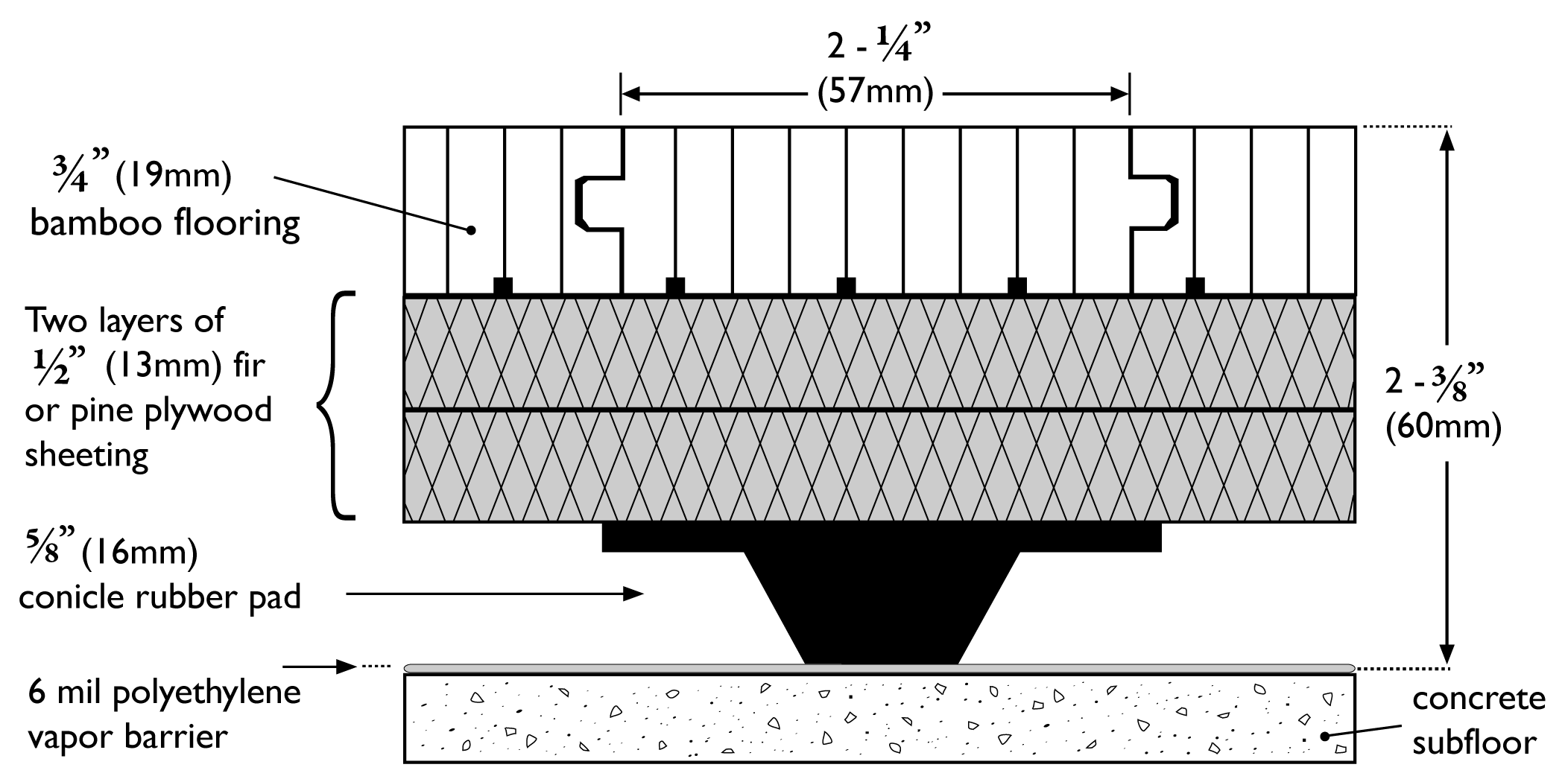

B. Test Results

System Information for PlybooSport Soft Touch – Y (EN Certified): aerobics, dance, yoga, stages

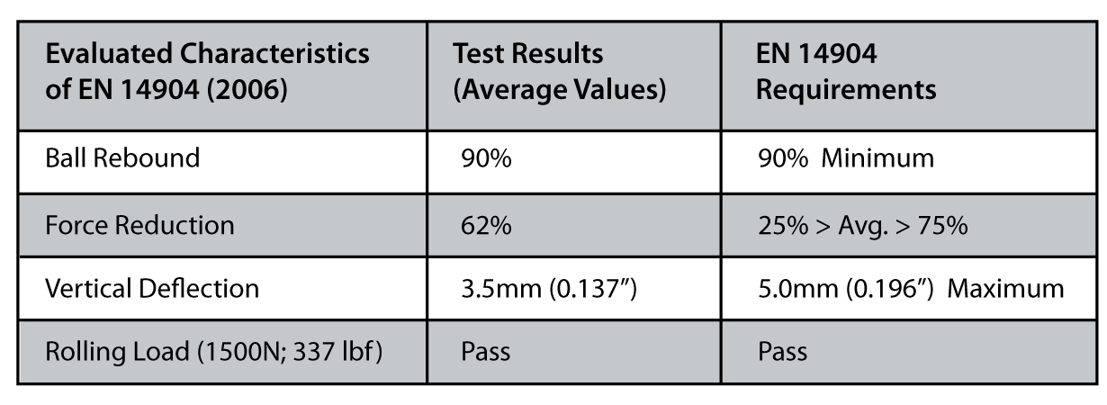

System Information for PlybooSport Multi-Use – W (DIN certified): gymnasiums, court related sports

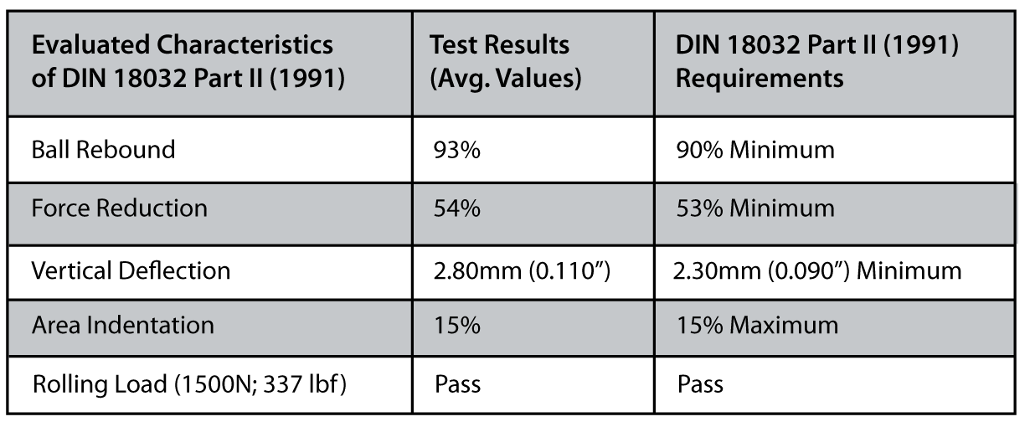

System Information for PlybooSport Pro – B (EN certified): gymnasiums, court related sports

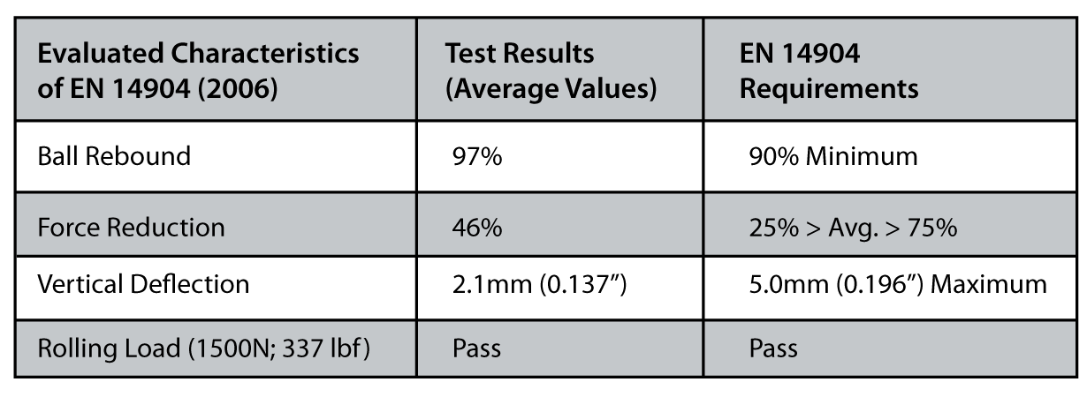

C. Diagram Details

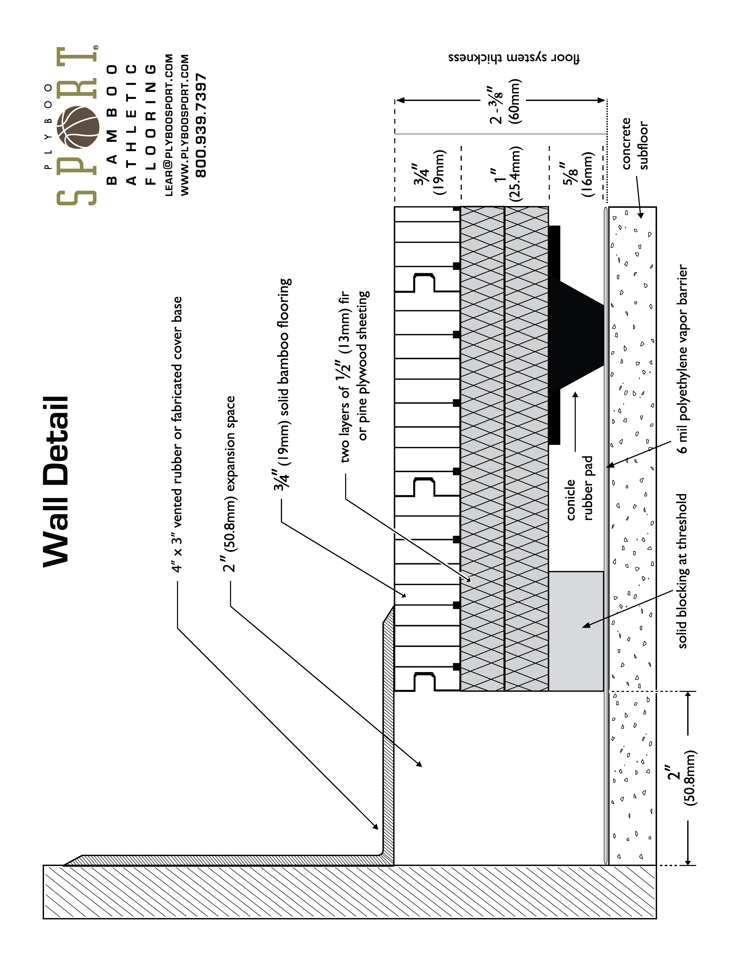

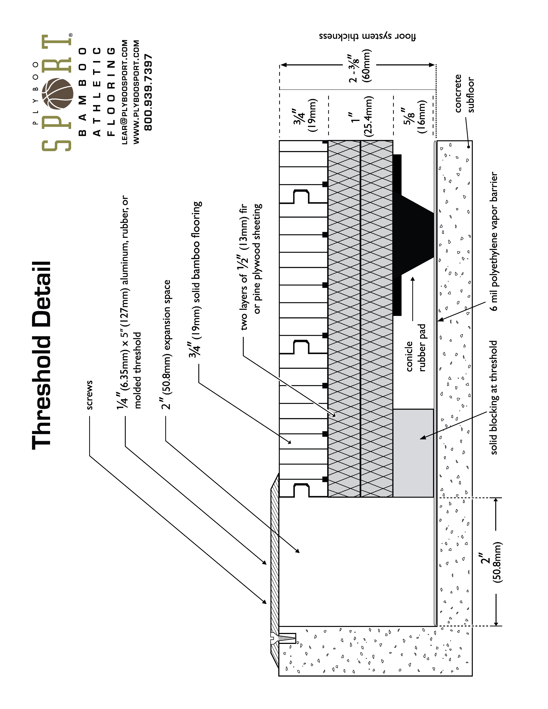
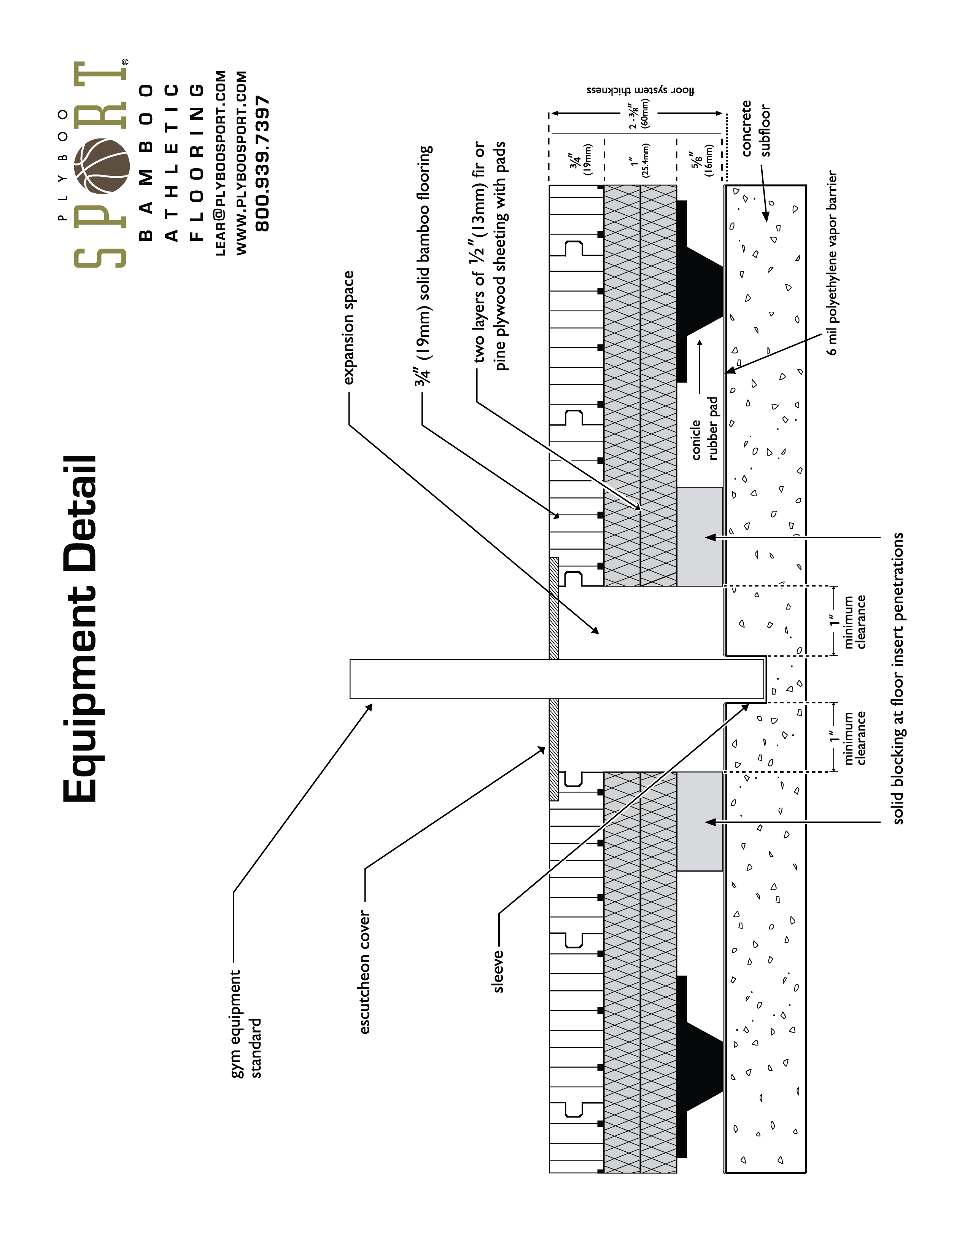

End OF PRODUCT SPECIFICATION

