  BAMBOO STRIP – athletic FLOORING  PLYBOOFIt®  FSC CERTIFIED  UREA FORMALDEHYDE FREE  product specification  in CSi 3-part format | Smith & Fong Company  475 – 6th Street  San Francisco, CA 94103  866-835-9859  (direct) 415.896.0577  (fax) 415.896.0583  website: www.plyboofit.com  e-mail: fit@plyboo.com      The mark of responsible forestry  SW-COC-003124  ©1996 Forest Stewardship Council A.C.
________________________________________________________________________________________
GENERAL NOTES TO SPECIFIER:

PLEASE GO TO wWW.PLYBOfit.COM and check in the specifications section TO VERIFY THIS IS THE MOST CURRENT VERSION.

THE FOLLOWING PRODUCT SPECIFICATION LANGUAGE IS INTENDED TO ASSIST DESIGN PROFESSIONALS IN specifying plyboofit® bamboo athletic floor surfaces in EXISTING 3-part specifications FOR PROPRIETARY or non-proprietary athletic floor systems.

THIS PRODUCT SPECIFICATION SPECIFIES THE BAMBOO STRIP GYMNASIUM FLOOR SYSTEM CONSISTING IN GENERAL OF BAMBOO FLOORING, WOOD SUBFLOORING, RUBBER pads,PADDING, VAPOR BARRIER, AND RELATED SURFACE FINISHING. THE SUBFLOor constructionS REFERENCE IS LOCATED IN pART 2: MATERIALS, AND PART 3: INSTALLATION.

SAMPLE LANGUAGE IS PROVIDED FOR APPLICABLE ARTICLES IN

PART 1–GENERAL,

PART 2–PRODUCTS,

part 3–execution FOLLOWING THE CONSTRUCTION SPECIFICATION INSTITUTE’S SECTIONFORMAT 4.0. BECAUSE OF THE VARIATION IN SPECIFICATION SYSTEMS CURRENTLY IN USE, ARTICLE AND PARAGRAPH numbers and TITLES MAY DIFFER SOMEWHAT THAN PRESENTED HEREIN. THE SAMPLE LANGUAGE SHOULD BE EDITED ACCORDINGLY TO FIT EACH FIRM’S SPECIFICATIONS.

ARTICLES AND PARAGRAPHS OF THIS PRODUCT SPECIFICATION ASSUME THE PROJECT MANUAL WILL CONTAIN COMPLETE DIVISION 1 DOCUMENTS INCLUDING 01 25 13−PRODUCT SUBSTITUTION PROCEDURES, SECTIONS 01 33 00−SUBMITTAL PROCEDURES, 01 62 00−PRODUCT OPTIONS, 01 66 00−PRODUCT STORAGE AND HANDLING REQUIREMENTS, 01 74 00−cLEANING and waste management, 01 77 00−CLOSEOUT PROCEDURES, AND 01 78 00−CLOSEOUT SUBMITTALS. CLOSE COORDINATION WITH DIVISION 1 SECTIONS IS REQUIRED. IF THE PROJECT MANUAL DOES NOT CONTAIN THESE SECTIONS, ADDITIONAL INFORMATION MAY BE INCLUDED UNDER THE APPROPRIATE ARTICLES.

NOTES TO THE SPECIFIER ARE IN ALL UPPER CASE TEXT AND ARE CONTAINED within rows of asterisks.

GREY HIGHLIGHTED GREEN TEXT AND NOTES RELATE TO LEED® PROJECTS.

OPTIONAL ITEMS REQUIRING SELECTION BY THE SPECIFIER ARE ENCLOSED WITHIN BRACKETS, E.G. [35] [40] [45]. MAKE APPROPRIATE SELECTIONS AND DELETE OTHERS.

INDEX

TOPIC | PAGE  #
GENERAL, SUMMARY, REFERENCES | 3
QUALIFICATION, SUBMITTALS, L.E.E.D | 5
WORKING CONDITIONS, PRODUCT | 5
WARRANTY, PRODUCTS, MANUFACTURERE CREDENTIALS | 6
COLORS | 7
PHYSICAL PROPERTIES, EXECUTION, INSPECTION | 8-11
INSTALLATION (by product) | 12-13
SUBFLOOR + ASSEMBLY DIAGRAMS,+ COMPONENTS (by product) | 14-15
CONTACT PlybooFiT | 1, 16

SECTION 09 64 66
Wood Athletic Flooring
PART 1 – GENERAL

  - SUMMARY/DESCRIPTION

  - PlybooFiT is a high performance athletic flooring system utilizing a Plyboo bamboo flooring top over a 1/4" single layer of 100% recycled rubber : PlybooFiT sports padding. (PFR 45B)

This FSC-certified, L.E.E.D contributing, FloorScore®certified system is designed for gymnasiums, aerobics, yoga, dance, exercise, stage, and general use room applications.

  - Related Sections

IN THE “RELATED SECTIONS” PARAGRAPH INCLUDE ALL DIVISION 01 SECTIONS CONTAINING LEED® REQUIREMENTS.

ADD TO OR DELETE FROM LIST BELOW TO CREATE AN ACCURATE LIST OF ALL APPROPRIATE SECTIONS FOR MATERIAL INSTALLED IN CONTACT WITH THE BAMBOO STRIP FLOORING.

ADD TO LIST BELOW SECTIONS FOR FINISHED TRIM NOT INCLUDED IN THIS SPECIFICATION.
______________________________________________________________________________________________

Section 03 30 00 – Cast-in-Place Concrete

(Floor slab placement, tolerancing, and finishing) Coordination with built-in sleeves.

Section 06 16 23 – Subflooring

Section 06 16 26 – Underlayment

Section 07 10 00 - Membrane Waterproofing
Concrete subfloor shall have adequate moisture barrier beneath and at the perimeter of the slab.

Section 08 71 00 – Finish Hardware – Thresholds, Baseboard

Section 11 49 00 – Gymnasium Equipment/Game Standards/Sleeves/Inserts

Section 23 09 00 – Instrumentation and Control for HVAC

Section 23 84 00 – Humidity Control Equipment

Section 01 04 00 - Submittals

1.02 REFERENCES

FSC – Forestry Stewardship Council

LEED® – Leadership in Energy and Environmental Design

USGBC – United States Green Building Council

ASTM – American Society for Testing and Materials

NWFA – National Wood Flooring Association

MFMA – Maple Flooring Manufacturers Association

FloorScore® – Resilient Floor Covering Institute (RFCI) and Scientific Certification Systems (SCS)

1.03 QUALITY ASSURANCE

Qualifications

INCLUDE THE FOLLOWING MANUFACTURER’S QUALIFICATIONS

MANUFACTURER

Bamboo Flooring Manufacturer’s Qualifications:

Minimum 15 years producing bamboo flooring and minimum five (5) years producing bamboo sports floors.

Manufacturer of bamboo flooring must be FSC, ISO 9001 and ISO 14001 certified to assure forestry, environmental, and quality control of materials provided.

Basis of design to be ‘PlybooFit’ sports floor system as provided by

Smith & Fong : PlybooFiT LLC … 866.835.9859 … www.plyboofit.com

Materials other than those listed from non-approved manufacturers will not be accepted.

Installer Qualifications:

Minimum five (5) years experience installing sports floors.

The installation of the floor system in these specifications shall be completed by an experienced sports floor installer (Flooring Contractor) familiar with the requirements of the system specified and fully experienced in procedures required to install athletic flooring manufactured by PlybooFiT-PlybooSport.

Installer shall be liable for all matter related to installation for a minimum period of 1 year after the floor has been substantially installed and completed.

INCLUDE THE FOLLOWING PRE-INSTALLATION MEETING REQUIREMENTS:
_________________________________________________________________________________________________

B. Pre-Installation Meeting:

Convene meeting at project site within one week of scheduled start of installation with representatives of the following in attendance: Owner, Architect, General Contractor, Flooring Sub-Contractor.

Review substrate conditions, requirements of related work, installation instructions, storage and handling procedures, and protection measures.

Keep and distribute minutes of meeting including responsibilities of various parties and deviations from specifications and installation instructions.

1.04 SUBMITTALS:

- Specification:
- Submit PlybooFiT specification sheets, FSC certification, L.E.E.D contribution and FloorScore® certificate.

Shop Drawing:
- Submit layout and installation shop drawings as requested by Specifier.
- Submit dimensional plans including location of all inserts, support sleeves, game lines, and logos.(if applicable)

Samples:
- Submit sample of assembled system as specified and requested by Specifier
- Submit 12” lengths of accessories, including bases, threshold, and striping paint colors

- Quality Assurance Submittals / Certificates:
- Submit Proof of Manufacturer’s Qualifications
- Submit Proof of Installing Contractor’s Qualifications
- Submit FSC certification

- Submit LEED submittals for MRc4, MRc6, MRc7, IEQc4 contributions
- MRc6, Rapidly Renewable Materials: Bamboo flooring [manufacturer’s product data for each product used, indicating that product(s) are manufactured from a rapidly renewable resource]
- MRc7, Certified Wood: Forest Stewardship Council [chain of custody certification verification from supplier of bamboo product(s)]
- MRc4 Recycled Content – Underlayment Padding materials
- IEQc4.3, Low-Emitting Materials – Flooring Systems [FloorScore certificated]

- Installer Supplied:
  - IEQc4.4, Low-Emitting Materials: Underlayment materials supplied by installer (manufactured with no added urea-formaldehyde)
  - IEQc4.1, Low-Emitting Materials: Adhesives and/or sealants [manufacturer’s product data]
  - IEQc4.2, Low-Emitting Materials: Paints and/or coatings [manufacturer’s product data for field finished floor coatings]

f. I.D. Innovation-in-Design
- Submit FloorScore certification
- Submit ISO 9001 and ISO 14001 certifications
- Submit Manufacturers recommended installation instructions (included)
- Submit Jobsite Test reports as requested by Specifier
- Air flow/ventilation testing
- Humidity level testing
- Room temperature testing
- Product moisture content testing
- Delivery and Storage reports
- Submit Maintenance Guidelines as requested by Specifier
- MSDS data
- Care, Maintenance and Service Guidelines
- HVAC temperature and humidity requirements
- Submit PlybooFiT-PlybooSport warranty

  - WORKING CONDITIONS, DELIVERY, STORAGE AND HANDLING

INCLUDE FOLLOWING REQUIREMENTS IN THE “DELIVERY, STORAGE AND HANDLING“ ARTICLE:

- Deliver bamboo flooring to Project site in original, unopened cartons, after all wet trades and overhead work is completed. The Building shall be full enclosed, weather-tight, with all permanent heat, light, windows, and doors installed.

Acclimatize bamboo flooring underlayment on site by opening all boxes and unwrapping the material. Test the moisture level of the bamboo and let acclimate to normal use room temperature and humidity conditions for a minimum of 72 hours before installation.

- Comply with MFMA Handling and Storage guidelines.
The concrete substrate shall be determined fully cured by industry standards, free of foreign materials and broom cleaned when turned over to the floor installer.

Permanent HVAC units shall be operating at least one week prior to PlybooFiT installation. Moderate room temperature of not less than 50°F (10°C) or more than 75°F (24°C) shall be maintained one week or more preceding, during and after the installation.

- Humidity: All wood and bamboo flooring will expand and contract as relative humidity varies. PlybooFiT bamboo sports flooring is manufactured at a moisture content most compatible with a 35% to 65% relative humidity range. Humidity conditions within the building shall approximate conditions which will prevail when the building is occupied. Care should be taken to maintain humidity within the range of 35% to 65%. Maintaining a 30% maximum fluctuation between highest and lowest average indoor relative humidity provides optimal conditions.

- Bamboo flooring must be stored on site in a dry, well-ventilated area and not in contact with masonry while acclimating to site conditions. Moisture content consistent with the ambient conditions of the building as it will be maintained while occupied.

- General Contractor shall lock floor area after floor is finished to allow proper curing time. If general contractor or owner requires use of area, they shall protect the floor by covering with no-marring Kraft paper or red rosin paper with taped joints until acceptance by owner of completed floor.

1.06 WARRANTY

__________________________________________________________________________________________

INCLUDE THE FOLLOWING WARRANTY:
__________________________________________________________________________________________

Smith & Fong PlybooFiT warrants that the athletic flooring sold under this warranty is at time of sale, free of defects in material and manufacture and adheres to PlybooFiT specifications. PlybooFiT warrants that when professionally installed and maintained in accordance with manufacturer’s instructions and used for intended purposes, PlybooFiT will not delaminate as a result of a manufacturing defect for a period of 25 years from date of sale (herein considered warranty period)

Warranty shall not cover damage in whole or in part by casualty, ordinary wear and tear, abuse, use for which materials are not designed, faulty installation, faulty construction of the building, settlement of building walls or concrete slab, failure of other contractors, separation of concrete slab, excessive dryness or excessive moisture from humidity, spillage, migration through concrete slab, walls or any other source. Abuse, vandalism, neglect, and improper installation or maintenance procedures will negate warranty.

During the warranty period, the floor shall not be recoated without the approval of the installing flooring contractor.

PART 2 – PRODUCTS

2.01 MANUFACTURER

    - Smith & Fong Company, San Francisco, CA 94103
  - Tel: (866) 835-9859.
  - E-mail: fit@plyboo.com
  - Direct: (415) 896.0577 – 866.835.9859
  - Website: http://www.plyboofit.com

2.02 MATERIALS 1 :

- PlybooFiT bamboo flooring product code: (select product code from sample binder or website and enter product code here)

Species: Moso (Phyllostachys Pubescens)

NAUF : No Added Urea Formaldehyde

FSC certified

FloorScore certified

Board Sizes:

Product | Thickness | Width | Length
Plyboo Bamboo | 5/8” (16mm) | 3 5/8” (92mm) | 72” (1829mm)
Plyboo Strand 9/16 | 9/16” (14mm) | 3 3/4” (95mm) | 72” (1829mm)
Plyboo Strand 3/8 | 3/8” (10mm) | 3 3/4" (95mm) | 36” (915mm)
Plyboo Squared | 5/8” (16mm) | 3 3/4" (95mm) | 37 3/4" (960mm)

_________________________________________________________________________________________________

Colors:

PlybooBamboo  5/8”x3 5/8”x72”  Prefinished or  Unfinished | 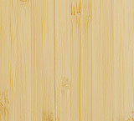  Edge Grain Natural  FL-V5872PN-NAUF/FSC  FL-V5872UN-NAUF/FSC | 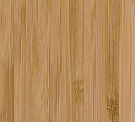  Edge Grain Amber  FL-V5872PA-NAUF/FSC  Fl-V5872UA-NAUF/FSC | 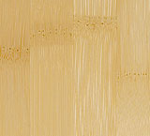  Flat Grain Natural  FL-5872PN-NAUF/FSC  FL-5872UN-NAUF/FSC | 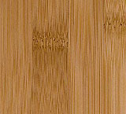  Flat Grain Amber  FL-5872PA-NAUF/FSC  FL-5872UA-NAUF/FSC
PlybooStrand  9/16”x3 ¾”x72”  Prefinished or  Unfinished | 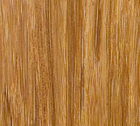  Sahara  FL-P5872PH-NAUF/FSC  FL-05872UH-NAUF/FSC | 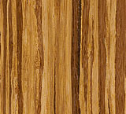  Neopolitan  FL-P5872-UNEO-NAUF/FSC  (unfinished only) | 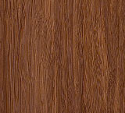  Havana  FL-P5872PD-NAUF/FSC  FL-P5836UD-NAUF/FSC
PlybooStrand  3/8”x3 ¾”x36”  Prefinished  Only | Sahara  FL-P3836PH-NAUF/FSC | Neopolitan  FL-P3836-NEO-NAUF/FSC | Havana  FL-P3836PD-NAUF/FSC
PlybooSquared  5/8”x 3 3/4”x 37 3/4"”  Prefinished or  Unfinished | 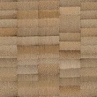  Squared Amberl  FL-EG5836PA-NAUF/FSC  FL-EG5836UA-NAUF/FSC | 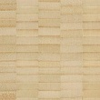  Squared Natural  FL-EG5836PN-NAUF/FSC  FL-EG5836UN-NAUF/FSC

________________________________________________________________________________________

flooring related trim & accessories :
 | 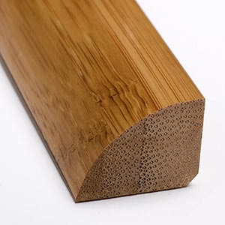 | base shoe | Prefinished natural & AMBER | 7/16” X 3/4” X 72”
 | 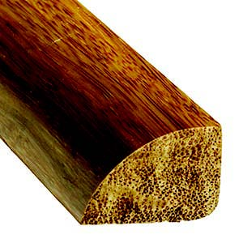 | base shoe | prefinished strand – havana, sahara, neopolitan | 7/16” X 3/4” X 72”
 | 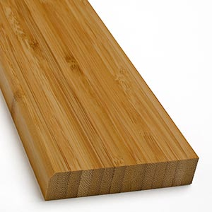 | BASEBOARD | Prefinished natural & amber, fLAT & EDGE GRAIN | 5/8” X 3” X 72”
 | 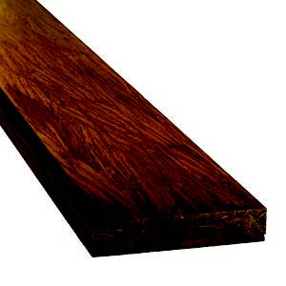 | baseboard | prefinished strand – havana, sahara, neopolitan | 5/8” X 3” X 72”
 | 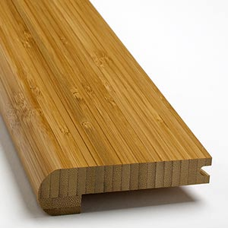 | STAIR NOSING | PREFINISHED NATURAL & AMBER, FLAT & EDGE GRAIN | 5/8” X 3 3/4” X 72”
 | 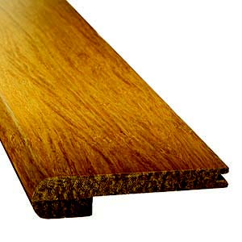 | stair nosing | prefinished strand – havana, sahara, neopolitan  prefinished strand – havana, sahara | 3/8” x 3/3/4” x 72”  9/16” x 3 3/4” x 72”
 | 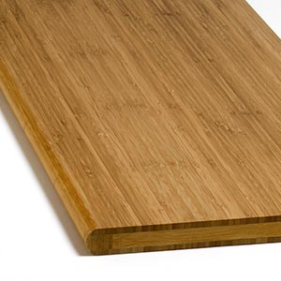 | STAIR STEPS | PREFINISHED NATURAL & AMBER, FLAT & EDGE GRAIN | 1” X 12” X 48”
 |  | stair steps | prefinished strand – havana, sahara | 1” x 12” x 48”
 | 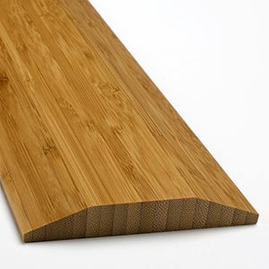 | THRESHOLD | PREFINISHED NATURAL & AMBER, FLAT & EDGE GRAIN | 5/8” X 3 5/8” X 72”
 | 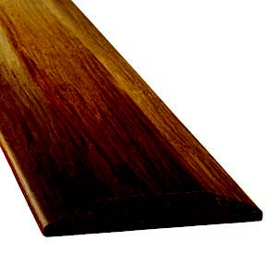 | threshold | prefinished strand – havana, sahara | 5/8” x 3 5/8’ x 72”
 | 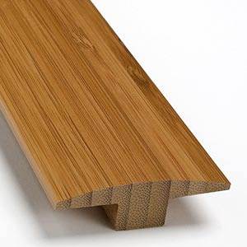 | T-MOLDING | PREFINISHED NATURAL & AMBER, FLAT & EDGE GRAIN | 5/8” X 2” X 72”
 | 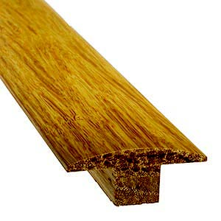 | t-molding | prefinished strand – havana, sahara | 3/8” x 2” x 72”  9/16” x 2” x 72”

7. Physical/Mechanical Properties: OF bAMBOO SURFACES
 | Product | Flammability  ASTM-E648 | Hardness  ASTM-D1307-99 | Dimensional Stability  ASTM-D1307-99-  AR 50%-to-20% RH | Compressive Strength  ASTM-D3501 | Moisture  Content  ASTM-D4442 | Volatile Organic  Emissions  ASTM-D5116-6  CA-01350
 | 5/8”  Flat grain | Class 1 | 1,900 lbf – natural  1,400 lbf- amber | Parallel = -0.04%  Perpendicular= -0.13%  Thickness Swell = -0.17% | Comprehensive Strength = 7,249 lbs  Max Load = 13,522 lbs | 6%-9% avg | PASSES  (No Added Formaldehyde)
 | 5/8”  Edge grain | Class 1 | 1,700lbf – natural  1,300lbf - amber | Parallel = -0.02%  Perpendicular= -0.7%  Thickness Swell = -0.34% | Comprehensive Strength = 6,160 lbs  Max Load = 12,201 lbs | 6%-9% avg | PASSES  (No Added  Formaldehyde)
 | 9/16”  Strand | Class 1 | 3,500 lbf -average | Parallel = -0.02%  Perpendicular= -0.23%  Thickness Swell = -0.25% | Comprehensive Strength = 9,340 lbs  Max Load = 13,140 lbs | 6%-9% avg | PASSES  (No Added Urea Formaldehyde)
 | 3/8”  Strand | Class 1 | 3,500 lbf-average | Parallel = -0.02%  Perpendicular= -0.23%  Thickness Swell = -0.25% | Comprehensive Strength = 9,340 lbs  Max Load = 13,140 lbs | 6%-9% avg | PASSES  (No Added Urea Formaldehyde)

__________________________________________________________________________________________________________________________________________________________________________________________________

- Underlayment: (padding)

PlybooFit – PFR-45B Rubber Padding: 1/4”x48”x50’ as supplied by PlybooFiT

Item | Test | Standard | Rating | 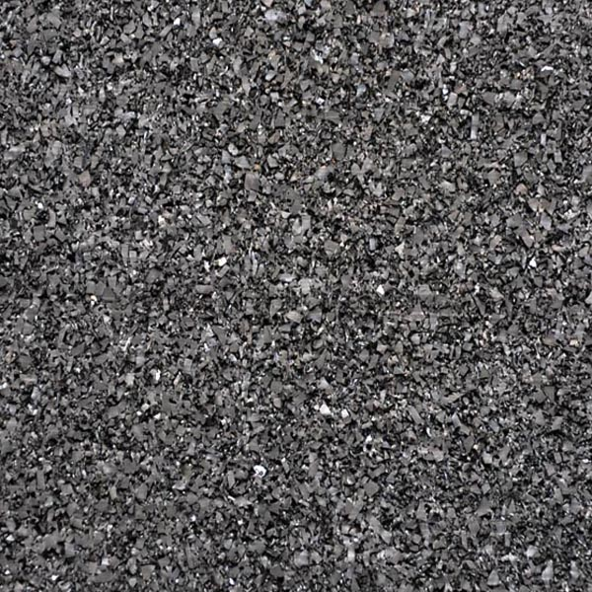
Sound  Impact Insulation | IIC | ASTM-E492  ASTM-E989 | 54 (over 6” concrete)  58 (over 6” concrete/6’ fiberglass)
Density | Pounds/cubic foot | ASTM-D3676 | 45pcf
Durometer | Shore A Hardness | ASTM-D2240 | 45 ±2
VOC’s | Closed Chamber  1.0m ±.05 m/3 | ASTM D5116 | SCQQMD
Flammability | Pill Test  (Methanamine) | DOC-FF 1-70 | Passed
Dimensions | 1/4" x 48” x 50’ |  |  | 48” x 50’ ft  200 sq.ft /roll
Weights | 1 lb /sq.ft. = 200# / roll |  |  | 200 lbs / roll

- Accessories:

- Polyurethane adhesive using appropriate trowel size per adhesive manufacturers recommendation:

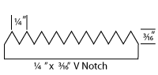 | 1/4" x 3/16”  (coverage approx 30-35 sq.ft./Gallon atop underlayment surface)  (verify coverage with selected adhesive and “test” patch for verification) | ¼” PlybooFiT padding

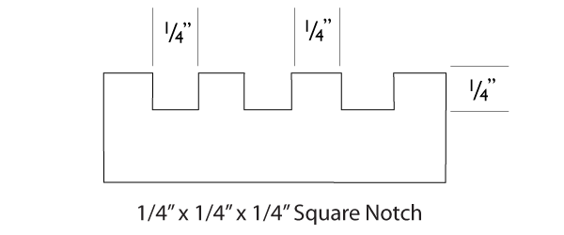 | ¼” x ¼” x ¼” Square Notch  (coverage approx 30-35 sq.ft./Gallon atop underlayment surface)  (verify coverage with selected adhesive and “test” patch for verification) | 3/4” Bamboo flooring
 |  | 5/8” Bamboo flooring
 |  | 9/16” Strand Bamboo
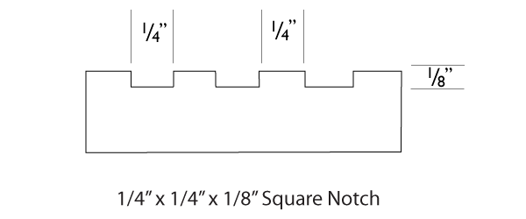 | ¼” x ¼” x 1/8” Square Notch  (coverage approx 30-35 sq.ft./Gallon atop underlayment surface)  (verify coverage with selected adhesive and “test” patch for verification) | 3/8” Strand bamboo

Installation Adhesive

Bostik Ultra-Set and Bostik Vapor-Lock adhesives and moisture abatement system are excellent product’s for PlybooFiT underlayment and Plyboo bamboo athletic flooring applications. www.bostik-us.com

Read and follow all instructions carefully for proper trowel size and adhesive set times.

- Finish Materials: for unfinished products consult PlybooFit for recommended finish materials.

- Graphics, Logo’s, Demarkation Lines (if applicable) : Compatible with Finish and as specified by layout design.

- Wall Base – as specified, Heavy Duty, molded or fabricated, vented cove base with pre-molded/pre-fabricated corners recommended or selected PlybooFit accessories.

______________________________________________________________________________________________________________________________________________________________________________
  - continued : Materials 2 :

PlybooFiT sports padding- #PFR-45B – (cushioning, insulating and acoustical material)
made from 100% post consumer recycled rubber. Contains NO VOC’s – formaldehydes, other aldehydes..

Item | Test | Standard | Rating
Sound  Impact Insulation | IIC | ASTM-E492  ASTM-E989 | 54 (over 6” concrete)  58 (over 6” concrete/6’ fiberglass)
Density | Pounds/cubic foot | ASTM-D3676 | 45pcf
Durometer | Shore A Hardness | ASTM-D2240 | 45 ±2
VOC’s | Closed Chamber  1.0m ±.05 m/3 | ASTM D5116 | SCQQMD
Flammability | Pill Test  (Methanamine) | DOC-FF 1-70 | Passed
Dimensions | 1/4" x 48” x 50’ |  |  | 48” x 50’ ft  200 sq.ft /roll
Weights | 1 lb/sq.ft. = 200# / roll |  |  | 20 lbs/ roll

PART 3 – EXECUTION

MODIFY THE FOLLOWING ARTICLE AS APPROPRIATE:

3.01 INSPECTION

- Inspect concrete slab for tolerance and dryness, and document/report any discrepancies to the general contractor/owner/specifier for rectification.

- Profile Rise/Slab depression : PlybooFiT

Product | Total  Profile | Components
Plyboo Bamboo  PlybooSquared | 7/8” | 5/8” flooring + ¼” PlybooFiT sports padding
PlybooStrand (9/16”) | 13/16” | 9/16” flooring + ¼” PlybooFiT sports padding
PlybooStrand (3/8”) | 5/8” | 3/8” flooring + ¼” PlybooFiT sports padding

The general contractor shall furnish and install the concrete subfloor depressing the slab sufficiently to accommodate the floor system. The slab shall be troweled smooth to a tolerance of 1/8” (3mm) in any 10’ (3m) radius by the general contractor. High spots shall be ground down and low spots filled in with approved leveling compound by the general contractor to the full approval of the sports floor installer

- The concrete slab will be dry, free of all debris and contaminants, and broom cleaned.

- Floor installer shall document site and working conditions prior to and during installation. This documentation shall become part of jobsite pedigree and warranty.

- Substrate and Product Moisture Testing :

  - Document substrate moisture content.

  - Document moisture content of PlybooFiT material (set meter for appropriate specific gravity).
(Wagner MMC-220 moisture meter used as calibrated standard
Product | Setting | Jobsite  reading %
5/8” edge grain natural | 0.61
5/8” edge grain amber | 0.65
5/8” end grain natural | 0.61
5/8” end grain amber | 0.65
5/8” flat grain natural | 0.63
5/8” flat grain amber | 0.62
9/16” & 3/8” Havana strand (dark) | 0.90
9/16” & 3/8” Sahara strand (light) | 0.79
9/16” & 3/8” Neopolitan (strand) | 0.86

  - Do not install PlybooFiT if wood substrate is used and exceeds 12% moisture or if moisture content difference between Sport Flooring material and wood substrate exceeds 3% difference.

  - Document use of Calcium Chloride Test in accordance with ASTM F-1869 if concrete substrate is used.

Jobsite | verified results  # / 1000 sq.ft / 24 hour period

  - Consult PlybooSport and Do Not install PlybooFit flooring if vapor emission from Calcium Chloride exceeds 3lbs moisture/1,000 ft²/24 hours (15g per m²). AND/OR

  - Document use of RH In-Situ Relative Humidity Test ASTM F-2170.

Jobsite | verified results  IN-SITU %

  - Do not install PlybooFiT flooring if RH test exceeds 75%.

- Documented tests results are required for PlybooFiT warranty.

Installation Guidelines begin next page

3.02 INSTALLATION

- Subfloor:
Inspect concrete slab for tolerance and dryness, and document/report any discrepancies to the general contractor/owner/specifier for rectification.

Profile Rise / Slab depression is:

Product | Profile | Components | Weight
Plyboo Bamboo  PlybooSquared | 7/8” | 5/8” flooring + ¼” PlybooFiT sports padding | approx 3 ½ lbs/sq.ft.
PlybooStrand (9/16”) | 13/16” | 9/16” flooring + ¼” PlybooFit sports padding | approx 4 ½ lbs/sq.ft.
PlybooStrand (3/8”) | 5/8” | 3/8” flooring + ¼” PlybooFiT sports padding | approx 3 ½ lbs/sq.ft

_________________________________________________________________________________________________

The general contractor shall furnish and install the concrete subfloor depressing the slab sufficiently to accommodate the floor system. The slab shall be troweled smooth to a tolerance of 1/8” (3mm) in any 10’ (3m) radius by the general contractor. High spots shall be ground down and low spots filled in with approved leveling compound by the general contractor to the full approval of the sports floor installer.

Installation Adhesive

Bostik Ultra-Set and Bostik Vapor-Lock adhesives and moisture abatement system are excellent product’s for PlybooFiT underlayment and Plyboo bamboo athletic flooring applications, due to their superior bonding and moisture vapor emission properties www.bostik-us.com

Read and follow all instructions carefully for proper trowel size and adhesive set times.
_________________________________________________________________________________________________

    - Acclimatize product for at least 72 hours before installation to allow adjustment to ambient conditions.
    - Verify room temperature of 50-75 degrees F and humidity range between 35-65%
    - Verify condition of slab and moisture vapor tests per ASTM F1869 and or ASTM F-2170
    - Verify moisture content of Bamboo Athletic Flooring material (per Wagner MMC-220 moisture meter settings)

5a Adhere the PlybooFiT sports padding rolls 90° perpendicular to the direction of the Plyboo flooring planks.

bamboo flooring direction | sports padding directionrection | 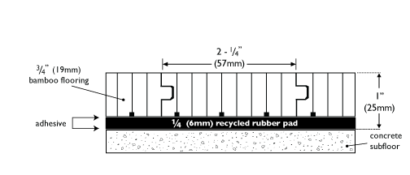
bamboo flooring direction | sports padding directionrection
5b Apply to subfloor with recommended one-part polyurethane adhesive using 1/4" x 3/16” inch V-notch trowel
Monitor the tooth size of the trowel blade frequently to ensure proper amount of adhesive is applied.

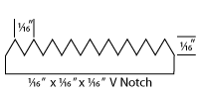

Adhere Bamboo Athletic Flooring material to PlybooFit underlayment using the recommended manufacturers
adhesives, trowels and installation recommendations.

 | 1/4” x 1/4” x 1/4” Square Notch  (coverage approx 25-30 sq.ft./Gallon atop sports padding surface)  (verify coverage with selected adhesive and “test” patch for verification)  Porosity of sports padding will yield approx 10%-12% less spread rate when compared to adhesive manufacturers guidelines. | 3/4” Bamboo flooring
 |  | 5/8” Bamboo flooring
 |  | 9/16” Strand Bamboo
 | 1/4” x 1/4” x 1/8” Square Notch  (coverage approx 32-35 sq.ft./Gallon atop sports padding surface)  (verify coverage with selected adhesive and “test” patch for verification)  Porosity of sports padding will yield approx 10%-12% less spread rate when compared to adhesive manufacturers guidelines. | 3/8” Strand bamboo

_________________________________________________________________________________________________

3.03 FLOOR FINISHING

- Sanding: (if unfinished product)
  - Machine sand to a smooth, even and uniform surface free from edger marks, drum drops, and stop marks.
  - Remove all sanding dust and lint by tack and vacuum.
  - Refer to MFMA/industry standards for finishing procedures.

- Finishing, Graphics, Logo’s, Demarkations,Gamelines:
    - Inspect entire floor to ensure surface is ready to accept seal and finish.
    - Apply (2) coats of approved seal and (2) coats of approved finish per manufacturers label instructions
    - Floor shall be buffed, cleaned and tacked between coats.
    - Apply logo’s, graphics, demarkation lines as indicated by Specifier drawings between seal and finish coats. Logo’s, graphics and demarcation lines paint shall be compatible with finish.

3.04 BASE INSTALLATION:

- Install cove base with cove base adhesive and/or mechanical attachment to wall. Use pre-molded outside corners and mitered inside corners. Miter all joints at 45° angles.

- Install cove base or PlybooFit baseboard, threshold’s and accessories.

3.05 CLEAN-UP/CLOSE-OUT

- Remove excess debris and waste material from the work area.

- General Contractor to protect the floor with non-marring Kraft paper.

3.06 MAINTENANCE

- Submit care and maintenance instructions of sealant and finish manufacturer as specified.
These guidelines will explain the proper finish maintenance requirements to assure proper floor performance and longevity

- HVAC Temperature, humidity and air ventilation controls must be operational and employed year round.

  - SYSTEM INFORMATION – diagrams
_________________________________________________________________________________________________

END VIEW DETAIL :
PF-BAMBOO-5872-0.875
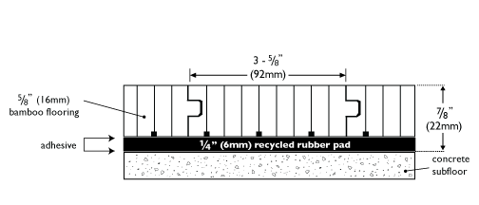

System Components Profile
Plyboo Bamboo Athletic Surface  5/8”x3 ¾”x72” (15mm x 92mm x 1829mm) | 5/8" | Top
1 layer of 1/4” PlybooFiT  100% post consumer content recycled rubber sports padding | 1/4” | Base
T O T A L profile | 7/8”
sports padding | 45 duro (#PFR45B)

END VIEW DETAIL :
PF-Squared-P5836-0.875
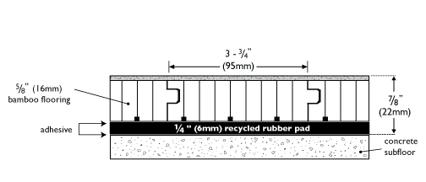

System Components Profile
PlybooSquared Bamboo Athletic Surface  5/8”x 3 ¾”x 37 3/4” (16mm x 95mm x 960mm) | 5/8” | Top
1 layer of 1/4” PlybooFiT  100% post consumer recycled rubber sports padding | 1/4" | Base
T O T A L profile | 7/8”
sports padding | 45 duro (#PFR45B)

END VIEW DETAIL :
PF-Strand-P5872-0.812
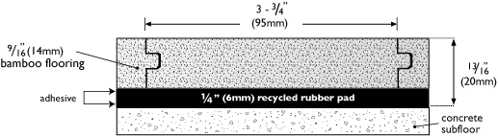

System Components Profile
PlybooStrand Bamboo Athletic Surface  9/16”x3 ¾”x72” (14mm x 95mm x 1829mm) | 9/6" |  | Top
1 layer of 1/4” PlybooFiT  100% post consumer content recycled rubber sports padding | 1/4” |  | Base
T O T A L profile | 13/16”
sports padding | 45 duro (#PFR45B)

END VIEW DETAIL :
PF-Strand-P3836-0.625
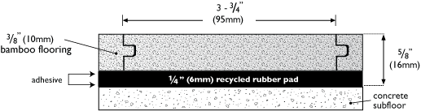

System Components Profile
PlybooStrand Bamboo Athletic Surface  3/8”x 3 ¾”x 72” (10mm x 95mm x 915mm) | 3/8" | Top
1 layer of 1/4” PlybooFiT  100% post consumer recycled rubber sports padding | 1/4” | Base
T O T A L profile | 5/8”
sports padding | 45 duro (#PFR45B)

End OF PRODUCT SPECIFICATION

866 . 835 . 9859

fit@plyboo.com

WWW.PLYBOOFIT.COM

